Student Name: |  | Teacher Name:
Grade: AC6th | Unit #: 5b | Unit Title: Applying Proportional Relationships
Approximate Start Date of Unit: |  | Approximate End Date (and Test Date) of Unit:
The following Statements and examples show the skills, concepts, and understandings that I will gain before the end of this unit.
(Initial in Box and & Date in the Space Provided When YOU CAN ) |  | I can plot pairs of values that represent equivalent ratios on the coordinate plane.
- The most common women’s shoe size in the U.S. is reported to be an $8$ $\frac{1}{2}$. A shoe store uses a table like the one below to decide how many pairs of size $8$ $\frac{1}{2}$ shoes to buy when it places a shoe order from the shoe manufacturers.

Total Number of Pairs of Shoes Being Ordered | Number of Pairs of Size $8$ $\frac{1}{2}$ to Order
$$50$$ | $$8$$
$$100$$ | $$16$$
$$150$$ | $$24$$
$$200$$ | $$32$$

  - What is the ratio of the number of pairs of size $8$ $\frac{1}{2}$ shoes the store orders to the total number of pairs of shoes being ordered?

  - Plot the values from the table on a coordinate plane. Label the axes. Then use the graph to find the number of pairs of size $8$ $\frac{1}{2}$shoes the store orders for a total order of $125$ pairs of shoes.

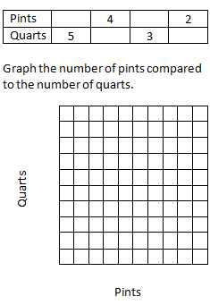  - There are 2 pints in one quart. Fill in the missing values. | - The graph shows the hours worked and total pay for Paul’s part-time job.  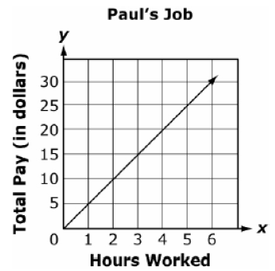  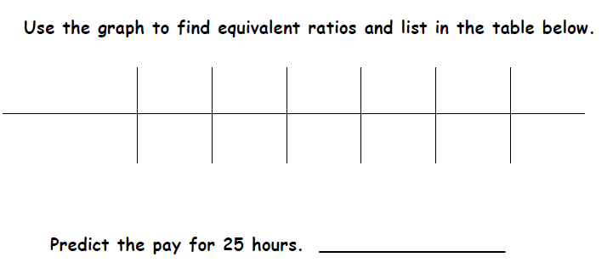
Hot Chocolate Temperature
Elapsed Time in Minutes | Temperature
5 | 180
10 | 165
15 | 140
20 | 130
25 | 125
30 | 120
35 | 115
40 | 112
- Mrs. Baker poured a cup of hot chocolate and set it on the table to cool. She recorded the temperature of the hot chocolate every 10 minutes. Here is her data:

- Plot the values from the chart.
- Does the graph show a ratio? How do you know? Support your answer from the table and the graph.

Student Notes/Comments/Questions:

(Initial in Box and & Date in the Space Provided When YOU CAN ) | I can analyze and describe patterns that arise from mathematical rules, tables, and graphs.
- Claire and Kate are entering a cup stacking contest. Both girls have the same strategy: stack the cups at a constant rate so that they do not slow down at the end of the race. While practicing, they keep track of their progress, which is shown below.

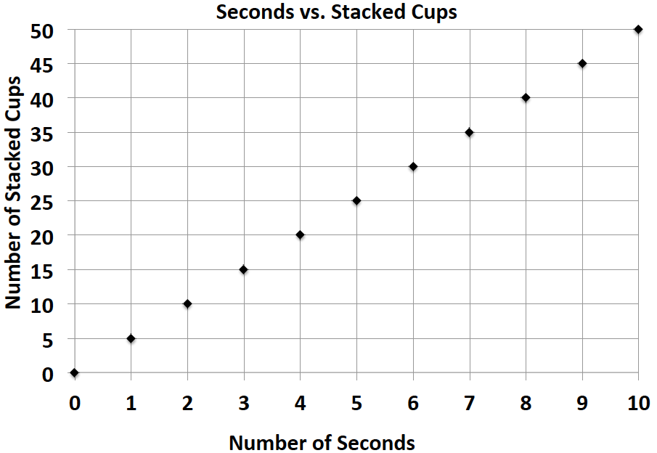
Claire: Kate: $c=4t$, where $t$ represents the amount of time in seconds and $c$ represents the number of stacked cups

- At what rate does each girl stack her cups during the practice sessions?

- Kate notices that she is not stacking her cups fast enough. What would Kate’s equation look like if she wanted to stack cups faster than Claire?

- Bryan and ShaNiece are both training for a bike race and want to compare who rides his or her bike at a faster rate. Both bikers use apps on their phones to record the time and distance of their bike rides. Bryan’s app keeps track of his route on a table, and ShaNiece’s app presents the information on a graph. The information is shown below.
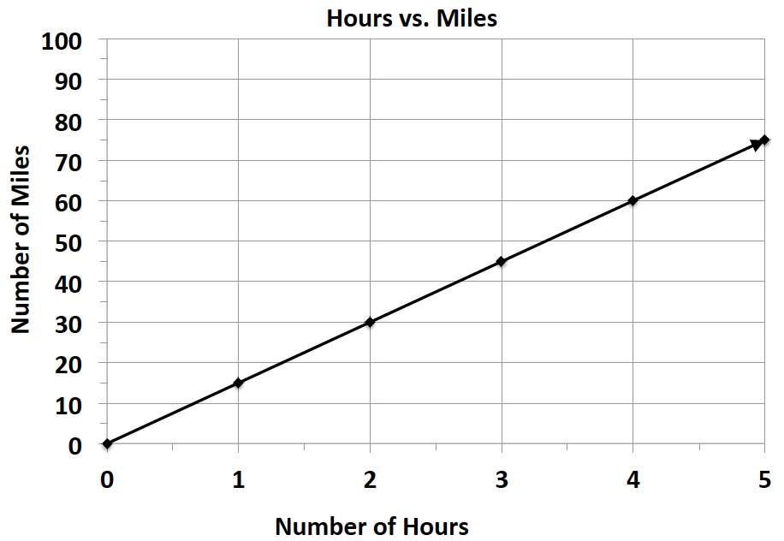
Bryan: ShaNiece:
Number of Hours | $$0$$ | $$3$$ | $$6$$
Number of Miles | $$0$$ | $$75$$ | $$150$$

  - At what rate does each biker travel? Explain how you arrived at your answer.

  - Was the manager correct? Why or why not?

- Victor was having a hard time deciding which new vehicle he should buy. He decided to make the final decision based on the gas efficiency of each car. A car that is more gas efficient gets more miles per gallon of gas. When he asked the manager at each car dealership for the gas mileage data, he received two different representations, which are shown below.
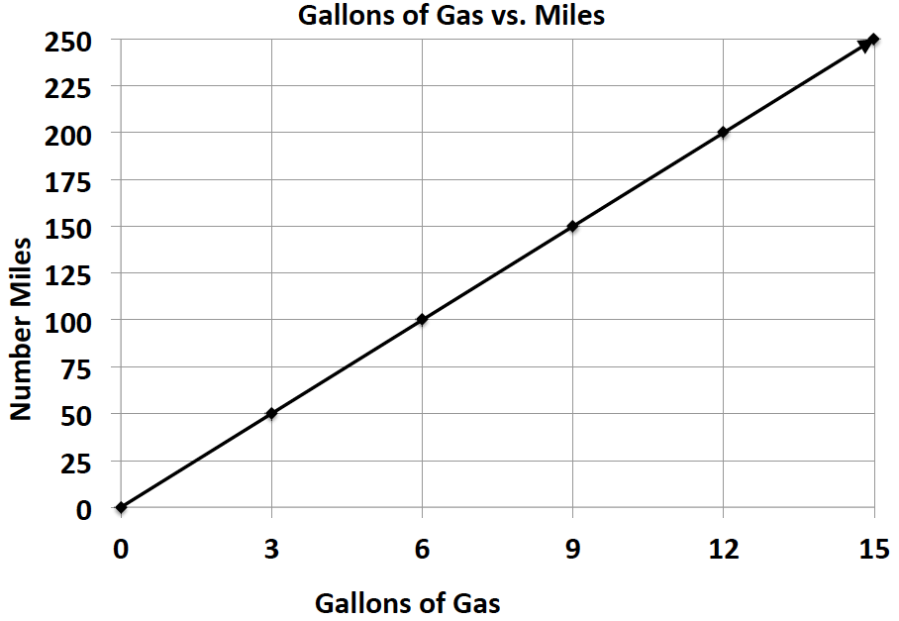
Vehicle 1: Legend Vehicle 2: Supreme
Gallons of Gas | $$4$$ | $$8$$ | $$12$$
Number of Miles | $$72$$ | $$144$$ | $$216$$

  - If Victor based his decision only on gas efficiency, which car should he buy? Provide support for your answer.

  - After comparing the Legend and the Supreme, Victor saw an advertisement for a third vehicle, the Lunar.
The manager said that the Lunar can travel about $289$ miles on a tank of gas. If the gas tank can hold $17$ gallons of gas, is the Lunar Victor’s best option? Why or why not?

- James can read 12 pages in 4 minutes.
  - Complete the following table:

Time to Read
Pages Read | Time in Minutes
12 | 4
24
36
48
60

  - Plot the values from the data table. Draw a line that best fits the data points, extending it beyond the first and last data points.

  - Use the graph to find the number of pages that can be read in 1 minute. Circle this point on the graph.

Student Notes/Comments/Questions:

(Initial in Box and & Date in the Space Provided When YOU CAN ) | I can define independent and dependent variables.  I can use variables to represent two quantities in a real-world problem that change in relationship to one another.  I can write an equation to express one quantity (dependent) in terms of the other quantity (independent).
EXAMPLES
- Joshua spends $25$ minutes of each day reading. Let $d$ be the number of days that he reads, and let$m$ represent the total minutes of reading. Determine which variable is independent and which is dependent. Then, write an equation that will model the situation. Make a table showing the number of minutes spent reading over $7$ days. | - Charlotte reads $4$ books each week. Let $b$ be the number of books she reads each week, and let $w$ be the number of weeks that she reads. Determine which variable is dependent and which is independent. Then, write an equation to model the situation, and make a table that shows the number of books read in under $6$ weeks.
- The table below shows the relationship between the number of cans and the weight of those cans in ounces.

Number of Cans | Weight (in ounces)
4 | 128
8 | 256
12 | 384

- What are the dependent and independent variables of this relationship?

Dependent variable ______________________________

Independent variable ______________________________

- Write an equation to represent the weight (W) for any number of cans (c).

- Use your equation to determine how much will 10 cans weigh (in ounces).

Student Notes/Comments/Questions

(Initial in Box and & Date in the Space Provided When YOU CAN ) | I can analyze the relationship between the dependent variable and independent variable using tables and graphs.  I can relate the data in a graph and table to the corresponding equation.
EXAMPLES
- Each week Quentin earns $\$30$. If he saves this money, create a graph that shows the total amount of money Quentin has saved from week $1$ through week $8$. Write an equation that represents the relationship between the number of weeks that Quentin has saved his money, $w$, and the total amount of money in dollars that he has saved, $s$. Then, name the independent and dependent variables. Write a sentence that shows this relationship.

- It takes one gallon of gas for Mr. Kraft to drive 12 miles in his truck. Mr. Kraft starts making a chart to show the number of miles, m, that can be driven based on a number of gallons of gas, g.  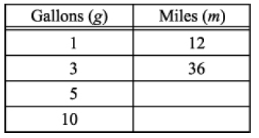  - Fill in the missing spaces in Mr. Kraft’s chart.  - Write an equation to show the relationship between the gallons of gas, g, and the number of miles driven, m. | - The table shows the relationship between the number of pineapples bought and the total cost.  Number Bought Total Cost  10 $25  15 $37.50  20 $50  30 $75  Write an expression to find the total cost of buying any number of pineapples. Use data from the chart to explain your answer.
- Maria is selling candy bars to raise money for her band trip. Each candy bar sells for $1.50. Use the graph paper to show a relationship between the number of candy bars Maria can sell and how much money she will receive.

- Write an equation to show total money earned (M) based on number of candy bars sold (b).

- Use your formula to show how much money Maria will receive if she sells 27 candy bars.

- If Maria needs to earn $110.00 for her band trip, what is the minimum number of candy bars she will need to sell?

Student Notes/Comments/Questions:

(Initial in Box and & Date in the Space Provided When YOU CAN ) | I can determine whether two quantities are proportional from either a table or graph.
EXAMPLES:
- Kayla made observations about the selling price of a new brand of coffee that sold in three different sized bags. She recorded those observations in the following table:  Ounces of Coffee $$6$$ $$8$$ $$16$$  Price in Dollars $$\$2.10$$ $$\$2.80$$ $$\$5.60$$  - Is the price proportional to the amount of coffee? Why or why not?  - Use the relationship to predict the cost of a $20$ oz. bag of coffee? | - The table below shows the relationship between the number of cars sold and the amount of money earned by the car salesperson. Is the amount of money earned, in dollars, proportional to the number of cars sold? Explain why or why not.  Number of Cars Sold Money Earned  $$1$$ $$250$$  $$2$$ $$600$$  $$3$$ $$950$$  $$4$$ $$1076$$  $$5$$ $$1555$$
- Determine whether or not the following graphs represent two quantities that are proportional to each other. Explain your reasoning.

  - b.

c.

- Sally’s aunt put money in a savings account for her on the day Sally was born. The savings account pays interest for keeping her money in the bank. The ratios below represent the number of years to the amount of money in the savings account.
- After one year, the interest accumulated, and the total in Sally’s account was $\$312$.
- After three years, the total was $\$340$. After six years, the total was $\$380$.
- After nine years, the total was $\$430$. After $12$ years, the total amount in Sally’s savings account was $\$480$.
Create a table and a graph, and explain whether the amount of money accumulated and the time elapsed are proportional to each other. Use your table and graph to support your reasoning.

Student Notes/Comments/Questions:

(Initial in Box and & Date in the Space Provided When YOU CAN ) | I can define constant of proportionality as a unit rate.
EXAMPLES:
- The dry cleaning fee for $3$ pairs of pants is $\$18$.  - What is the constant of proportionality?  - How much will the dry cleaner charge for $11$ pairs of pants? | - Your friend uses the equation $C=50P$ to find the total cost, $C$, for the number of people, $P$, entering a local amusement park.  - Is the cost of admission proportional to the amount of people entering the amusement park? Explain why or why not.  - What is the unit rate and what does it represent in the context of the situation?

Student Notes/Comments/Questions:

(Initial in Box and & Date in the Space Provided When YOU CAN ) | I can represent proportional relationships by writing equations.
EXAMPLES:
- In $25$ minutes Li can run $10$ laps around the track. Determine the number of laps she can run per minute.  - Find the constant of proportionality in this situation.  - Write an equation to represent the relationship. | - Oscar and Maria each wrote an equation that they felt represented the proportional relationship between distance in kilometers and distance in miles. One entry in the table paired $152$ km with $95$ miles. If$k$ represents the number of kilometers and $m$represents the number of miles, who wrote the correct equation that would relate miles to kilometers? Explain why.  Oscar wrote the equation $k=1.6m$, and he said that the rate $\frac{1.6}{1}$ represents kilometers per mile.  Maria wrote the equation $k=0.625m$as her equation, and she said that$0.625$represents kilometers per mile.
- On average, Susan downloads $60$ songs per month. An online music vendor sells package prices for songs that can be downloaded on to personal digital devices. The graph below shows the package prices for the most popular promotions. Susan wants to know if she should buy her music from this company or pay a flat fee of $\$58.00$ per month offered by another company. Which is the better buy?
  - Find the constant of proportionality for this situation.
  - Write an equation to represent the relationship.
  - Use your equation to find the answer to Susan’s question above. Justify your answer with mathematical evidence and a written explanation.
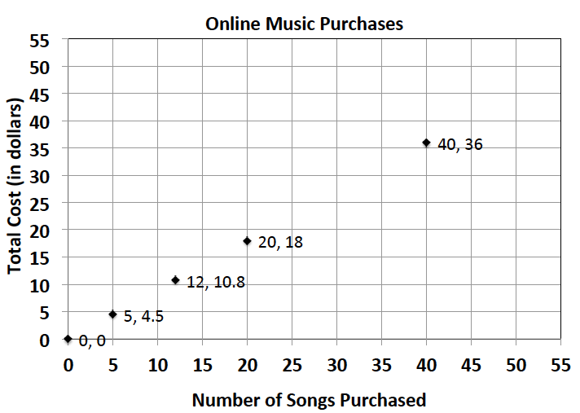

- In Katya’s car, the number of miles driven is proportional to the number of gallons of gas used. Find the missing value in the table.
The Number of Gallons | The Number of Miles Driven
0 | 0
$$4$$ | $$112$$
$$6$$ | $$168$$
 | $$224$$
$$10$$ | $$280$$
  - Write an equation that will relate the number of miles driven to the number of gallons of gas.
  - What is the constant of proportionality?
  - How many miles could Katya go if she filled her $22$-gallon tank?
  - If Katya takes a trip of $600$ miles, how many gallons of gas would be needed to make the trip?
  - If Katya drives $224$ miles during one week of commuting to school and work, how many gallons of gas would she use?

Student Notes/Comments/Questions

(Initial in Box and & Date in the Space Provided When YOU CAN ) | I can explain what (0, 0) represents on the graph of a proportional relationship.  I can recognize what (1, r) on a graph represents, where r is the unit rate.  I can explain what the points on a graph of a proportional relationship means in terms of a specific situation.
EXAMPLES:
- When a song is sold by an online music store, the store takes some of the money and the singer gets the rest. The graph below shows how much money a pop singer makes given the total amount of money brought in by one popular online music store from sales of the song.

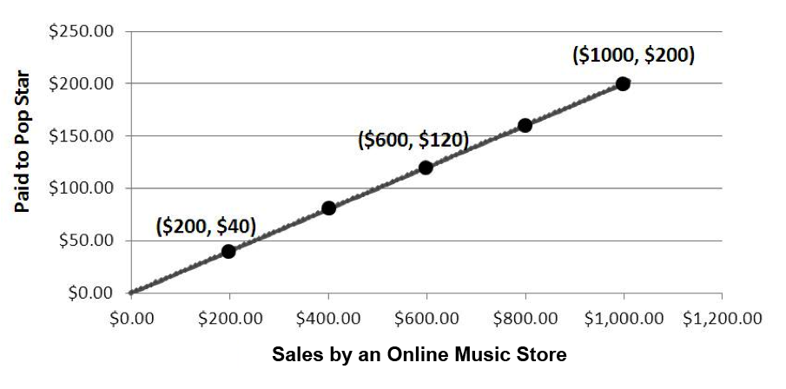

- According to the proportional relationship, how much money did the song bring in from sales in the first week if the pop star earned $\$800$ that week?

- Describe what the point $(0,0)$ on the graph represents in terms of the situation being described by the graph.

- Which point on the graph represents the amount of money the pop singer gets for $\$1$ in money brought in from sales of the song by the store?

- The graph below shows the amount of time a person can shower with a certain amount of water.
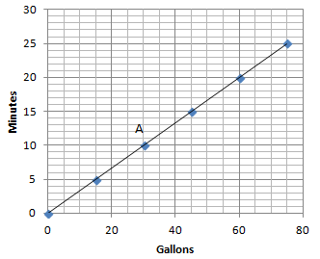
  - How long can a person shower with $15$ gallons of water How long can a person shower with $60$ gallons of water?

- What are the coordinates of point $A$? Describe point $A$ in the context of the problem.

- Can you use the graph to identify the unit rate?

- Great Rapids White Water Rafting Company rents rafts for $\$125$per hour. Explain why the point $(0,0)$and $(1,125)$ are on the graph of the relationship, and what these points mean in the context of the problem.

Student Notes/Comments/Questions

