Unit 5b Study Guide:   
Applying Proportional Relationships

Vocabulary:

1. ___________: a statement that shows two mathematical expressions are equal

2. ___________ __________: pairs of operations that undo each other.

Addition and subtraction are inverse operations. For example, 1 + 4 = 5, and 5 - 4 = 1. Multiplication and division are inverse operations. For example, 2 x 3 = 6, and 6 ÷ 3 = 2.

3. ___________: A number (or ordered pair of numbers, or set of numbers) that produces a true statement when substituted for the variable(s) in an equation or inequality.

4. ____________ ___ ______________: The constant value of the ratio of two proportional quantities x and y; usually written y = kx, where k is the constant of proportionality. In a proportional relationship, y = kx, k is the constant of proportionality, which is the value of the ratio between y and x.

5._____________ _____________ The relation between two quantities whose ratio remains constant. When one variable increases the other increases proportionally: When one variable doubles the other doubles, when one variable triples the other triples, and so on. When A changes by some factor, then B changes by the same factor: A=kB, where k is the constant of proportionality.

6. ____________: A relationship in which each member of one set is paired with exactly one member of another set.

7. ____________ ___________: An equation whose solution is a straight line.

8. ______________: A mathematical sentence that contains the symbols >, <, ≥, or ≤.

Part A:

Solving One-Step Equations

9. X + 319 = 2084 10. Y – 482 = 912

Check: Check:

11. 2.5h = 80 12.  = 20.1

Check: Check:

13.  + w =  14. 2  a = 1 

Check: Check:

15. 1.2y = -144 16. = -0.6

Check: Check:

17. -1.8 + v = -3.8 18. - + m = -

Check: Check:

19. y - w = - 20. -v = -

Check: Check:

21. When 17 is subtracted from a number, the result is 64. Write an equation that can be used to find the original number. Then find the original number.

Equation: ___________________________

Solution: ____________________________

22. During a sales trip, Mr. Jones drove 15 miles east from Brownsville to Carlton. Then he drove several more miles east from Carlton to Sun City. The distance from Brownsville to Sun City is 35 miles. Write and solve an addition equation to find how many miles it is from Carlton to Sun City.

Equation: ___________________________

Solution: ____________________________

23. Ted took 17 pictures at the aquarium. He now has 7 pictures left on the roll. Write and solve a subtraction equation to find out how many photos Ted had when he went to the aquarium.

Equation: ___________________________

Solution: ____________________________

24. A hot-air balloon flew at 10 miles per hour. Using the variable *h*, write and solve a multiplication equation to find how many hours the balloon traveled if it covered a distance of 70 miles.

Equation: ___________________________

Solution: ____________________________

25. There are 16 ounces in one pound. A box of nails weighs 4 pounds. Using the variable *w*, write and solve a division equation to find how many ounces the box weighs.

Equation: ___________________________

Solution: ____________________________

Part B:

**Function Tables/Graphing**

26. Complete the function table. What is the rule? _______________

|  |  |
| --- | --- |
| INPUT  (X) | OUTPUT  (Y) |
| 1 | 60 |
| 2 | 120 |
| 3 | 180 |
| 4 |  |
| 5 |  |

27. Movies are rented for $2.50 at Video-Rama. What is the charge to rent *x* number of movies?

First, write the function. __________

Second, create a function table. Third, graph the function.

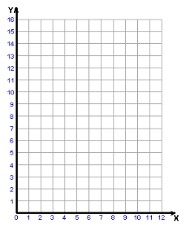

28. The table below shows the total number of pencils in different numbers of packages.

Write an equation that could be used to find the total number of pencils, *y*, in *x* packages. _____________

Then graph the function.

|  |  |
| --- | --- |
| NUMBER OF PACKAGES  (X) | NUMBER OF PENCILS  (Y) |
| 2 | 12 |
| 3 | 18 |
| 5 | 30 |
| 6 | 36 |



29. **Write the equation that represents the relationship shown in the table. ________________**

|  |  |
| --- | --- |
| X | Y |
| 0 | 3 |
| 1 | 5 |
| 2 | 7 |
| 3 | 9 |

30. Eric makes wooden puzzle boxes. The graph shows the number of dollars, d, Eric earns for each puzzle box, b, he sells. List the ordered pairs shown on the graph. Which is the independent variable? Which is the dependent variable? Write an equation that expresses the relationship between the number of puzzle boxes sold and the amount Eric earns.

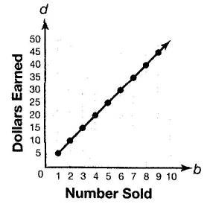

Ordered Pairs:_____________________________

Independent: ______________________________

Dependent: _______________________________

Equation: _________________________________

Part C:

**Direction Proportions/Variation**

**Tell whether the following tables are examples of direct variation. If so, write the equation and identify the constant of proportionality**

|  |  |  |  |  |
| --- | --- | --- | --- | --- |
| X | 1 | 2 | 3 | 4 |
| Y | 2 | 4 | 6 | 8 |

|  |  |  |  |  |
| --- | --- | --- | --- | --- |
| X | 1 | 2 | 3 | 4 |
| Y | 5 | 7 | 9 | 11 |

31. 32.

|  |  |  |  |  |
| --- | --- | --- | --- | --- |
| X | 1 | 2 | 3 | 4 |
| Y | 60 | 30 | 20 | 15 |

|  |  |  |  |  |
| --- | --- | --- | --- | --- |
| X | 1 | 2 | 3 | 4 |
| Y | 3 | 6 | 9 | 12 |

33. 34.

**Tell whether each illustrates direct variation or not. If not, tell why.**

35. Number of people who like HEB donuts and the number of donuts that are sold at HEB.

36. The number of apple pie eaters at a party and the number of apple pie remaining at the end of the party.

State whether or not the plotted points could show a direct proportion relationship. **If they could, write the equation and identify the constant of proportionality.**

37. 38. 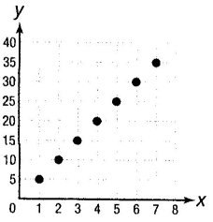 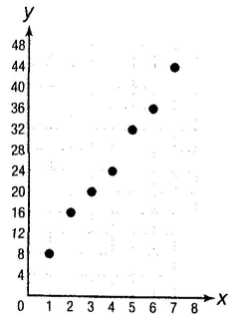

_____________________________________ __________________________________

39. **There are 47 skittles in a bag.**

**Complete the table below.**

|  |  |
| --- | --- |
| # of Bags | Total # of Skittles |
| 1 | 47 |
| 2 | 94 |
| 3 | 141 |
| 4 |  |
| 5 |  |
| 6 |  |
| 7 |  |
| 8 |  |
| 9 |  |

Using the table, write an equation using y = kx. __________________

What is the constant of proportionality? ___________

Use the formula to determine how many skittles there would be in 50 bags. ________________________

Part C:

**Inequalities**

Write an inequality for each situation.

40. The temperature today will be at most 50˚ F. ______________________

41. The temperature tomorrow will be above 70° F. ___________________

42. Yesterday, there was less than 2 inches of rain. ___________________

43. Last Monday, there was at least 3 inches of rain. ___________________

Solve each inequality. Then graph each solution set on a number line.



44. > 14



45. c – 17 ≤ -6



46. -25 > y – 53



47. k + 3.2 ≥ 8

48. c - 6 < -1



49. > 1.4





50. -5z > -3



51. < -13



52. ≥ 12

53. 5.6v ≥ -14



Write an inequality for each word problem and then solve.

54. There are at least 17 more bus riders than walkers in a class. If there are 7 walkers, how many bus riders are there?

Inequality: _____________________ Solution: ________________________

55. In order for a field trip to be scheduled, at least 30 students must sign up. So far, 23 students have signed up. At least how many more students must sign up in order for the field trip to be scheduled?

Inequality: _____________________ Solution: ________________________

56. It cost Sophia $530 to make wind chimes. How many wind chimes must she sell at $12 apiece to make a profit?

Inequality: _____________________ Solution: ________________________

57. Greg’s soccer team is having its annual fundraiser. The team hopes to earn at least three times as much as it did last year. Last year the team earned $87. What is the team’s goal for this year?

Inequality: _____________________ Solution: ________________________